

2026-27
  - September - March

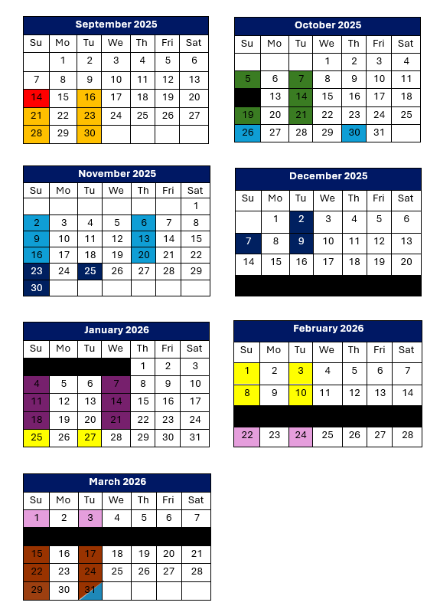

Schedule

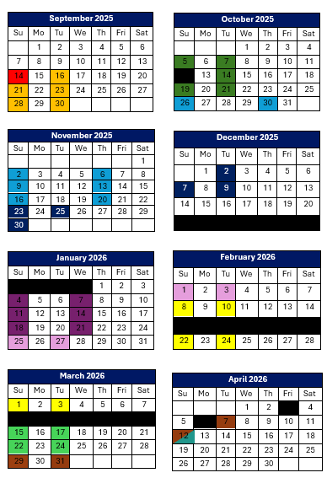
Kick-Off Day
Sun @ SAJS
5:00-5:45 PM (Team Blue)
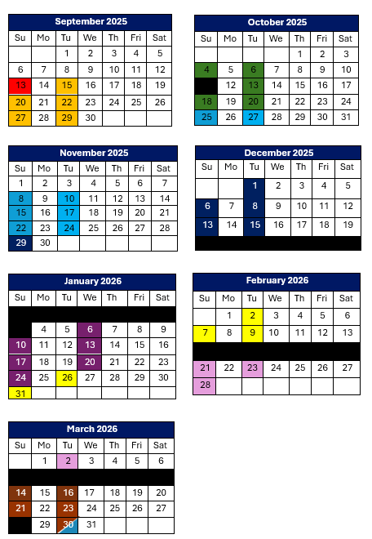
6:00-6:45 PM (Team White)
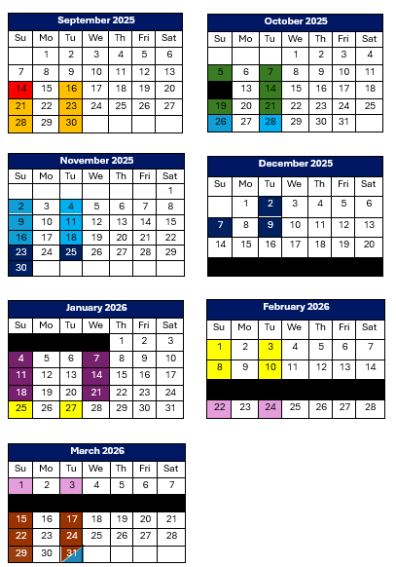
Baseball/Softball
Tues & Sun @ Sandlot Field
5:00-5:45 PM (Team Blue)
6:00-6:45 PM (Team White)

Net & Racquet Sports
Tues & Sun @ SAJS
5:00-5:45 PM (Team Blue)
5:45-6:30 PM (Team White)

Hockey
Sundays @ STFX Main Rink
4:30-5:15 PM (Team Blue)
5:30 – 6:15 PM (Team White)
Tuesdays @ STFX AUX Rink
4:15-5:15 PM (Both Teams)

Athletics
Sun & Tues @ SAJS
5:00-5:45 PM (Team Blue)
6:00-6:45 PM (Team White)

Swimming
Sunday & Wednesday @ STFX
5:00-5:45 PM (Team Blue)
6:00-6:45 PM (Team White)

Gymnastics
Sun & Tues @ STFX AUX GYM
5:00-5:45 PM (Team Blue)
6:00-6:45 PM (Team White)

Basketball
Sun & Tues @ SAJS
5:00-5:45 PM (Team Blue)
6:00-6:45 PM (Team White)
CONTACT INFORMATION
antigonishmultisport@gmail.com
902-318-4048
Soccer
Sun & Tues @ SAJS
5:00-5:45 PM (Team Blue)
6:00-6:45 PM (Team White)

Wrap-Up Celebration
Tuesday March 30 @ SAJS
Final 15 minutes to celebrate with staff!

Holidays/Breaks

